**Assignment-3**

Assignment Question. 01: Write a program in C to make such a pattern like right angle triangle with a number which will repeat a number in a row.

The pattern like:

1

22

333

4444

CODE

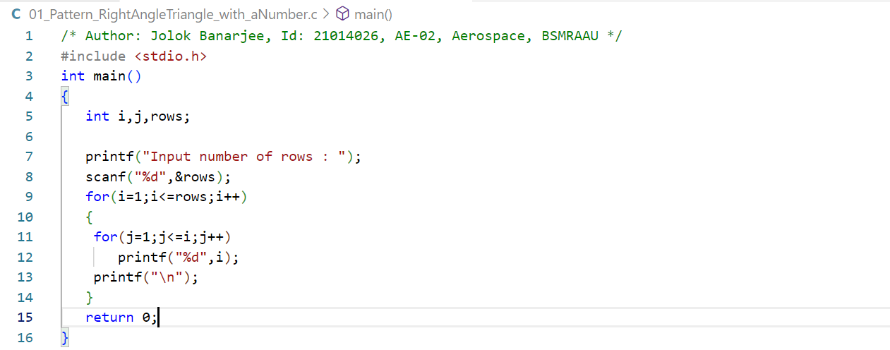

OUTPUT

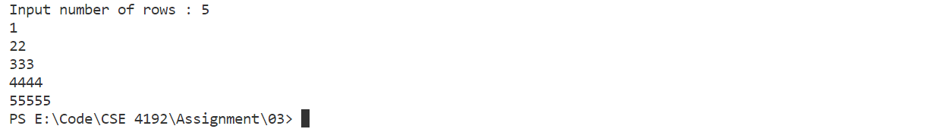

Assignment Question 2: Write a C program to calculate the factorial of a given number using for loop.

Sample input: 5

Sample Output: 120

CODE

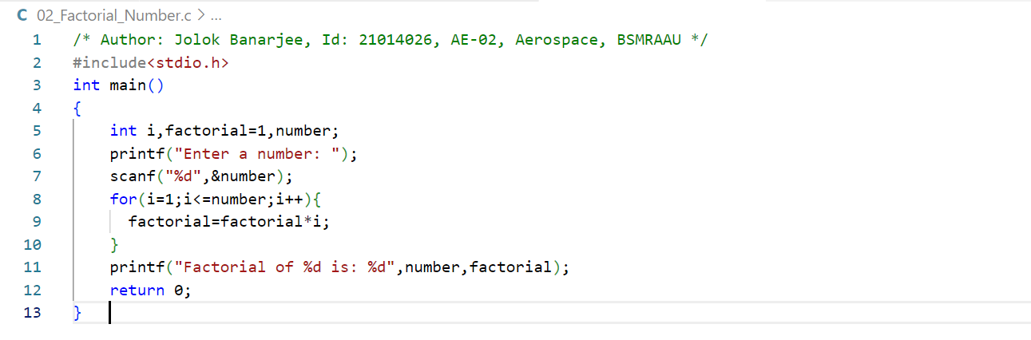

OUTPUT



Assignment Question 3: Write a program in C Program to Check Whether a Number is Prime or Not.

CODE

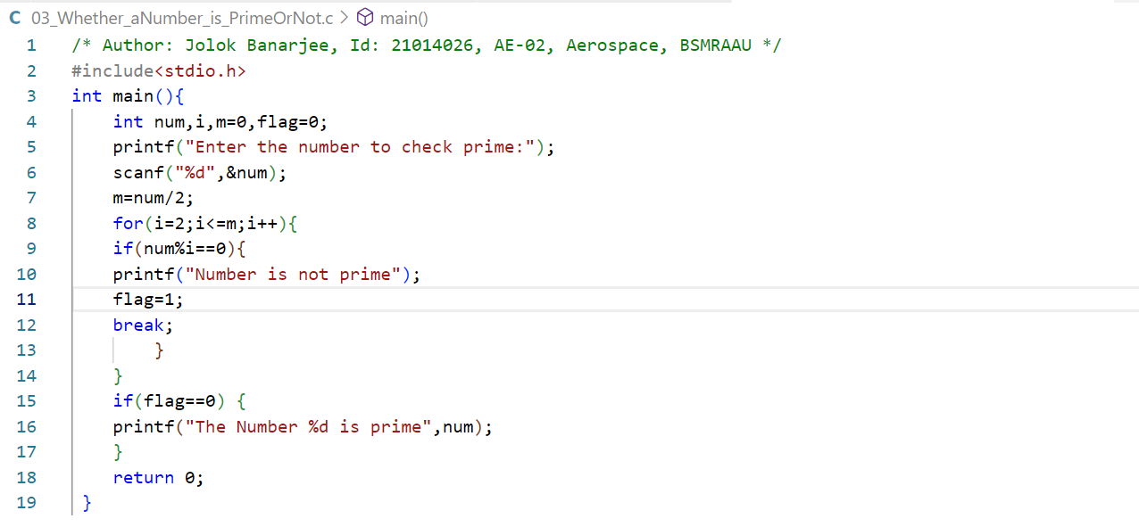

OUTPUT1



OUTPUT2



Assignment Question 4: Write a C program to reverse a number from user input.

CODE

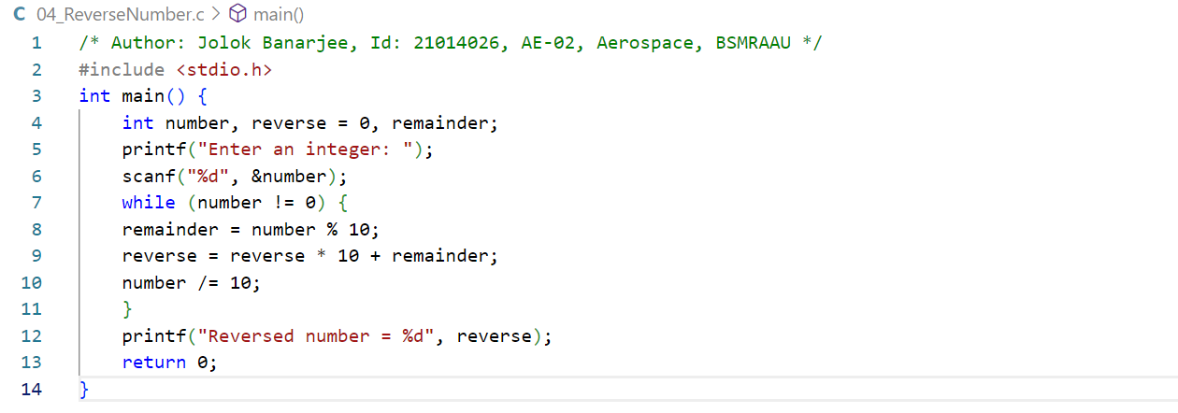

OUTPUT



**Lab Work-3**

Lab Work Question 1: C program to Natural number using for loop.

CODE

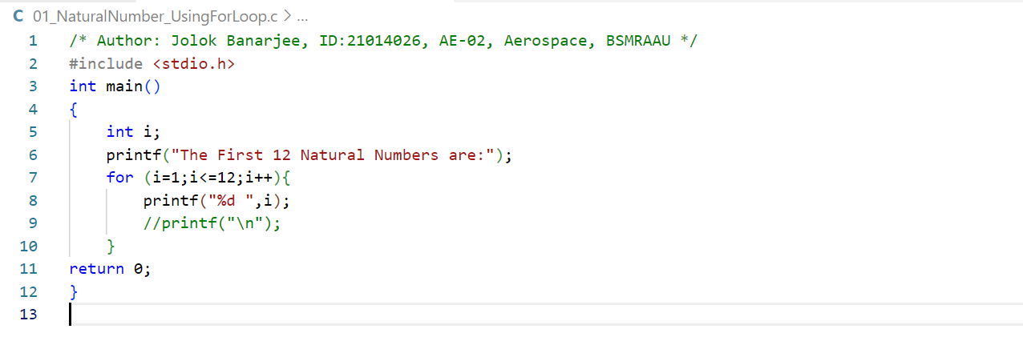

OUTPUT



Lab Work Question 2: C program Triangle by using nested for loop.

CODE

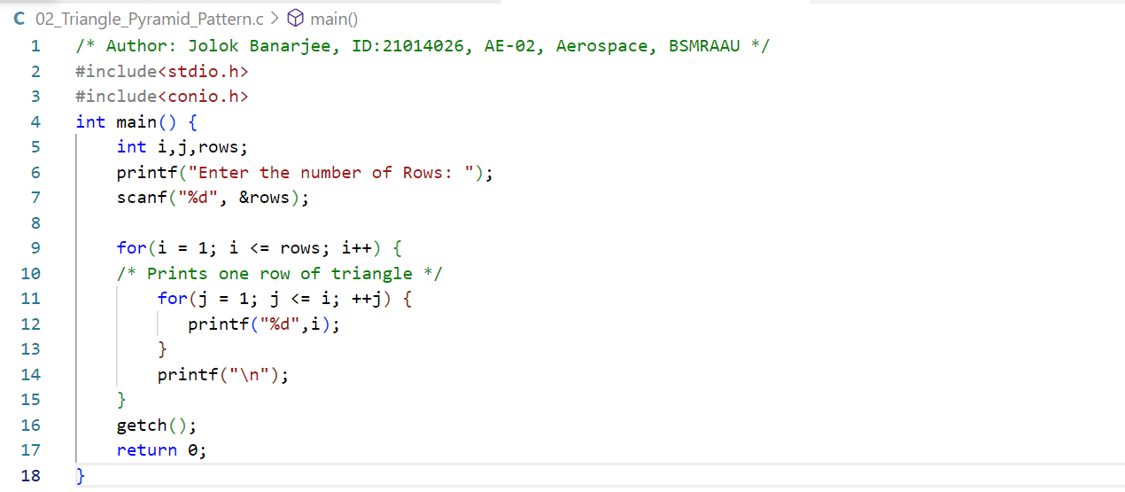

OUTPUT

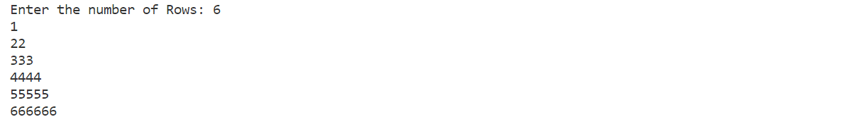

Lab Work Question 3: C program for Reverse Triangle by using nested for loop.

CODE

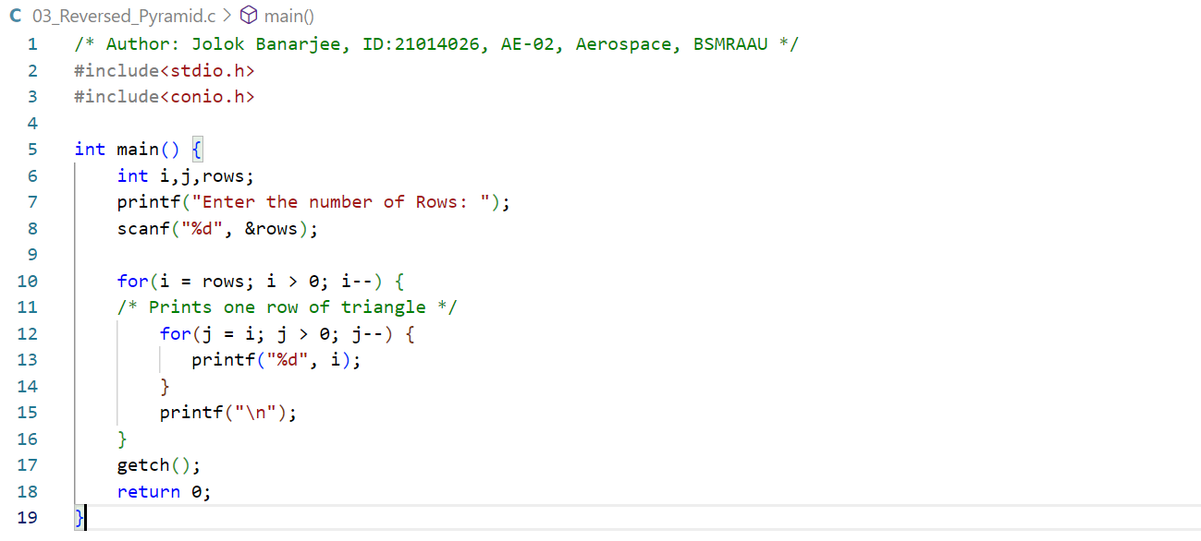

OUTPUT

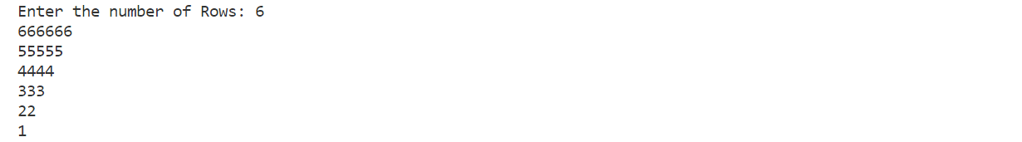

Lab Work Question 4: C program for 1 to 20 sum of natural number.

CODE

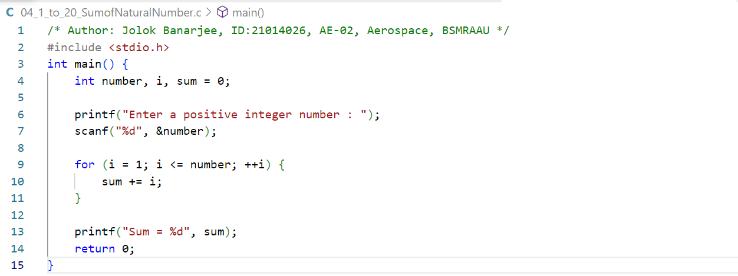

OUTPUT

